Cells: Activity Board Chapter 2
Complete the activity marked with an apple. Then choose 3 other activities to complete. All 4 must be turned in by Monday, January 30th. If time allows, you may choose to do more of the activity boxes for extra credit.

Illustrate and label the prokaryotic and eukaryotic cell on page 45. Explain the difference between each. Color is required.

Create a “Flap book” of the Vocabulary. Attach to your activity board.

Create a crossword puzzle using Chapter 2 vocabulary words. Include definitions.

Create a rap for the organelles inside the cell. It must rhyme and you may perform it in front of the class. Descriptions for each are required.

Write a narrative on the “A day in the life of a cell” and explain what happens inside a cell every day. Use personification to make the cell come to life in your narrative.

Create a poster analyzing the difference between a cell to tissue to organ to organ system relationship. Use arrows and descriptions on the poster.

Assignment Rubric:
1. Student demonstrated clear understanding of the task. 1 2 3 4 5
2. Student stays on task during work time and uses class time wisely. 1 2 3 4 5
3. Student’s work is neat, legible, and demonstrates student’s best effort. 1 2 3 4 5
4. Student turns in the minimum number of activities on time. 1 2 3 4 5
Total _______ X 5 = __________ grade

Complete Chapter 2
Section Reviews.

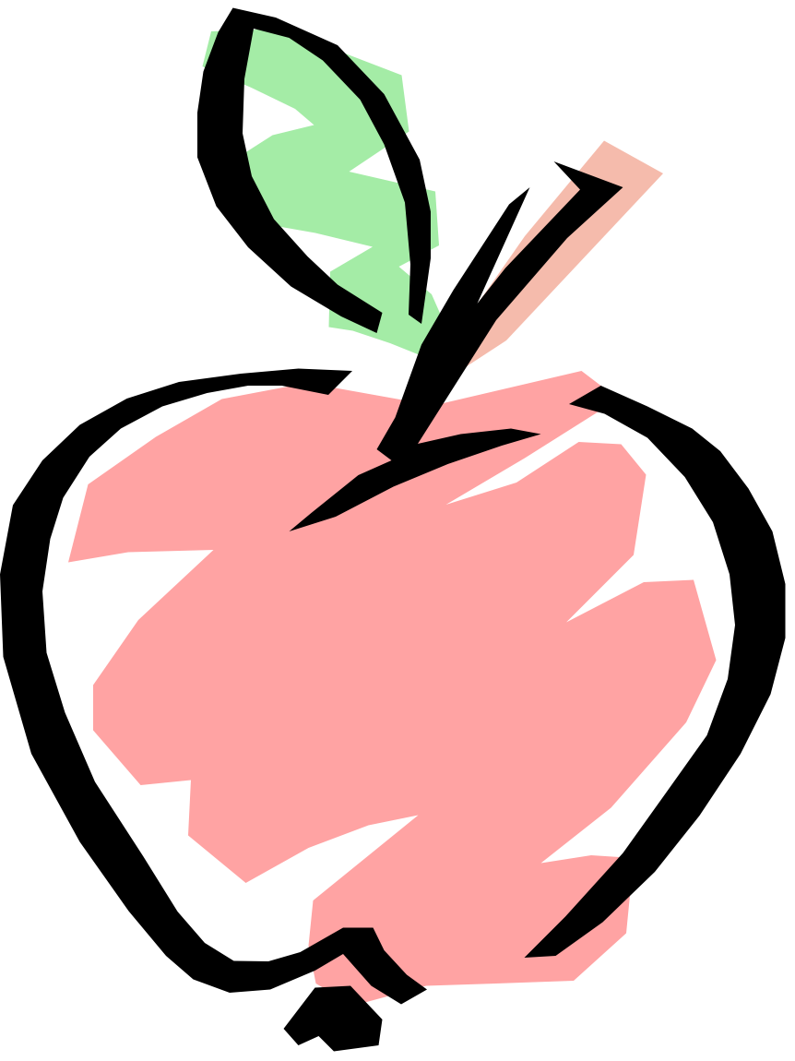
Find pictures on the internet of plant cells and paste them inside an illustration of the plant. Then, describe the cells and how they carry their daily functions.

Research the “Cell Theory” online and write two paragraphs explaining what you found to be interesting.

